PROJECT DOCUMENTATION

Northstar Fintech Risk Operations Project Guide
  - A simple explanation of the business problem, user workflow, technology, and lessons from real financial incidents
Northstar is a fictional transaction monitoring dashboard built to demonstrate how software engineering supports fraud and financial crime operations.

Project type | Interactive front-end demonstration
Domain | Fintech, banking, payments, fraud risk, and AML operations
Technology | HTML, CSS, and JavaScript
Data | Synthetic demonstration data only
Prepared | 6 October 2026

Important: Northstar does not connect to a bank, process payments, or make real risk decisions.

Project overview

What Northstar demonstrates
A bank may process thousands of payments through cards, UPI, NetBanking, and international transfer systems. Northstar brings suspicious activity into one screen so a risk analyst can understand what happened, review the evidence, and record a decision.
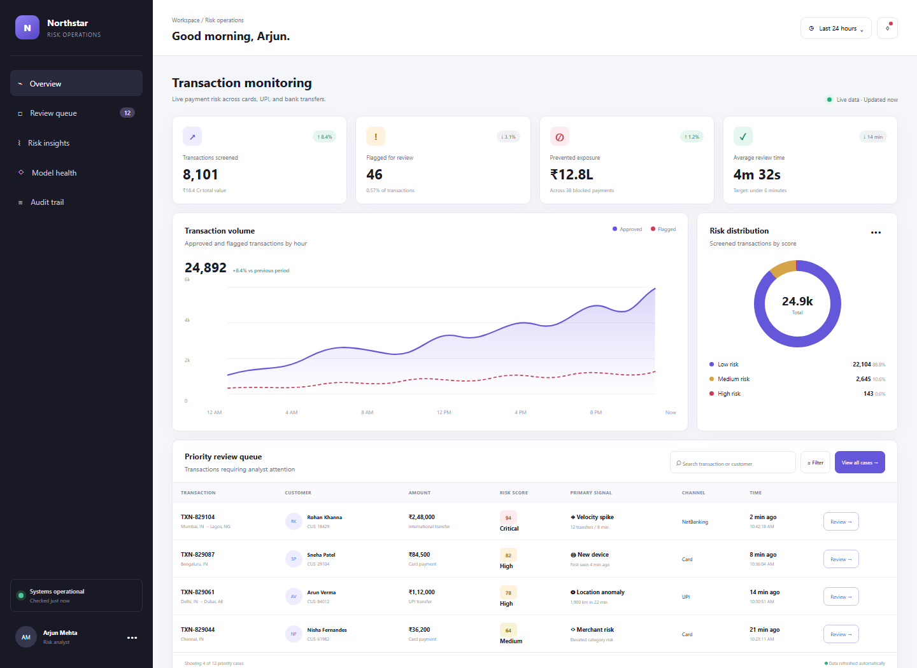
Figure 1 Northstar dashboard with risk metrics, charts, and the priority review queue
The values shown in the interface are examples. They make the workflow easy to demonstrate without exposing real customer or bank information.

Business context

The problem the project solves
Payment systems must make decisions quickly, but a suspicious transaction often needs human judgment. Analysts need the transaction details, the reason it was flagged, the customer context, and a safe way to record the outcome.

Who would use this system
- Fraud analysts review unusual payments and possible account takeover.
- AML investigators examine behavior that may indicate money laundering or mule accounts.
- Risk managers monitor exposure, queue size, review time, and false positives.
- Auditors and compliance teams check whether decisions were supported and recorded.

Why both technology and BFSI matter
The technology side must receive events, calculate signals, search cases, protect customer data, and keep reliable records. The banking side defines what counts as unusual, which decisions require approval, how long records must be kept, and when a case should be escalated.

Project boundary
The current project is a browser-based demonstration. It focuses on the analyst experience. A real deployment would add payment integrations, authentication, case APIs, databases, encryption, monitoring, and regulatory controls.

User workflow

How a transaction is reviewed
Northstar represents a simple decision path. Low-risk payments may continue automatically. Medium- and high-risk payments enter the review queue, where an analyst checks the evidence and records an outcome.
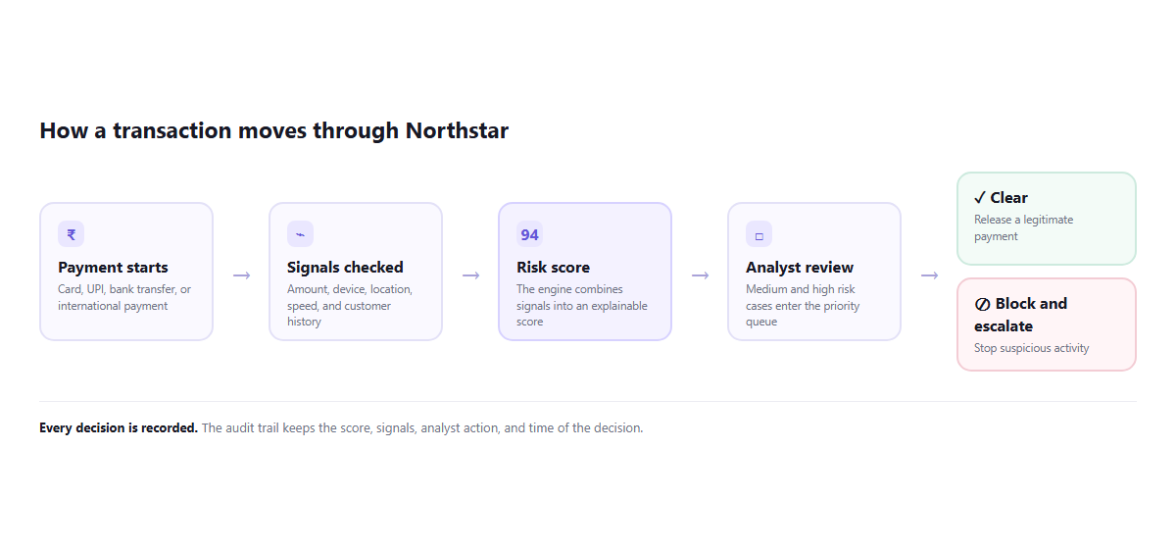
Figure 2 Simplified transaction screening and review flow

Example walkthrough
A customer sends a large international transfer. The engine notices twelve transfers in eight minutes and assigns a risk score of 94. The case appears at the top of the queue with the velocity signal. An analyst reviews the payment route and customer history, then either clears the transaction or blocks and escalates it. Northstar displays a confirmation and treats the action as an audit event.

Dashboard guide

What each section means
Section | What it shows | Why it matters
Key metrics | Transactions screened, cases flagged, prevented exposure, and review time | Gives managers a quick operational view
Volume chart | Approved and flagged payments by hour | Makes spikes and changes easier to notice
Risk distribution | Low, medium, and high-risk proportions | Shows whether the queue is growing unusually
Review queue | Customer, amount, score, signal, channel, and time | Helps analysts handle the highest-risk cases first
Case review | Reason for the alert and transaction context | Supports an explainable decision
Model health | Precision, recall, and false-positive rate | Shows whether detection quality is changing

A few important risk signals
- Velocity spike means many payments occurred in a short period.
- New device means the payment came from a device that the customer has not used before.
- Location anomaly means the location changed faster than normal travel would allow.
- Merchant risk means the merchant or category has an elevated risk profile.
A signal is a reason to investigate. It is not proof that the customer committed fraud.

Technology design

How the demonstration could become a real system
The current interface runs entirely in the browser. A production system would separate the user interface from transaction ingestion, scoring, case management, storage, and audit services.
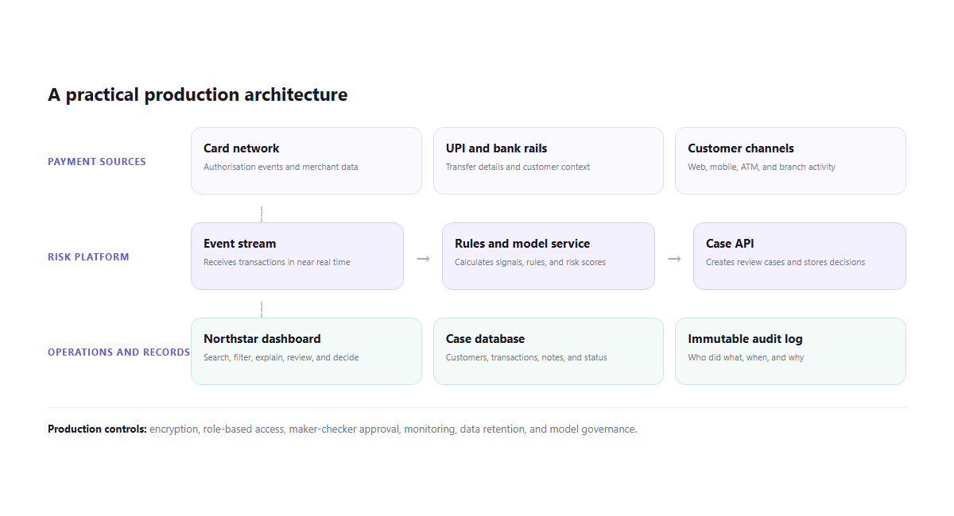
Figure 3 Suggested production architecture for Northstar

Current project files
index.html | Defines the dashboard, sample transactions, tables, charts, and case dialog.
styles.css | Controls the visual design, responsive layout, tables, charts, and mobile navigation.
script.js | Handles search, risk filters, case review, decisions, notifications, and number animation.
README.md | Provides a short project summary and explains that the data is synthetic.

Real case example 1

Bangladesh Bank SWIFT theft
In February 2016, attackers stole USD 81 million from Bangladesh Bank. According to the United States Department of Justice, the attackers compromised the bank network after spear-phishing activity, reached terminals connected to the SWIFT system, and sent fraudulently authenticated transfer messages. The money moved to accounts in other Asian countries. [1]

What this case teaches
- A payment message can look technically valid even when the system that created it has been compromised.
- Monitoring must consider new beneficiaries, unusual countries, abnormal values, timing, and repeated transfer attempts.
- Strong endpoint security, payment approval, reconciliation, and escalation are as important as the dashboard.

Connection to Northstar
Northstar could place an unusual international transfer at the top of the review queue and explain which behaviors drove the score. In a real bank, the case would also need beneficiary screening, sanctions controls, dual approval, and rapid communication with payment operations.

Simple scenario
Observed behavior | A high-value payment is sent to a newly added overseas beneficiary outside the customer's normal operating hours.
Possible signals | New beneficiary, unusual country, value anomaly, and unusual time.
Analyst action | Pause the transaction, verify the customer request through an independent channel, and escalate if the evidence remains suspicious.

Real case examples 2 and 3

Capital One cloud risk enforcement action
In August 2020, the US Office of the Comptroller of the Currency assessed an USD 80 million civil money penalty against Capital One. The OCC said the bank had not established effective risk assessment processes before moving significant information technology operations to the public cloud and had not corrected identified deficiencies in a timely manner. [2]

Northstar lesson
A well-designed dashboard cannot compensate for weak infrastructure controls. A production version needs secure cloud configuration, access controls, monitoring, vulnerability management, and evidence that problems are fixed.

RBI restrictions on Paytm Payments Bank
In February 2024, the Reserve Bank of India modified earlier directions issued to Paytm Payments Bank under Section 35A of the Banking Regulation Act. The directions stopped further deposits, credit transactions, and wallet or FASTag top-ups after 15 March 2024, with listed exceptions, and restricted additional banking services while allowing customers to use available balances. [3]

Northstar lesson
Regulatory controls affect product behavior and customer operations. A fintech system must support clear restrictions, accurate customer status, controlled exceptions, timely reporting, and an audit trail that shows how each rule was applied.

How the three cases connect
Case | Main risk | Project connection
Bangladesh Bank | Fraudulent payment instructions after a cyber intrusion | Transaction signals, escalation, and payment controls
Capital One | Technology and cloud risk management | Secure architecture, monitoring, and remediation
Paytm Payments Bank | Regulatory restrictions on payment operations | Rule enforcement, customer status, and auditability

Production roadmap

What would be added for real-world use
The next version should keep the current interface but replace synthetic browser data with controlled services and persistent records.
Area | Production addition | Reason
Identity | Single sign-on, role-based access, and maker-checker approval | Limits access and separates sensitive decisions
Data | Encrypted customer and transaction storage | Protects personal and financial information
Integration | Event streaming and payment APIs | Receives transactions reliably and quickly
Detection | Versioned rules and model-serving APIs | Makes scores repeatable and governable
Cases | Database-backed notes, evidence, ownership, and status | Supports investigation from alert to closure
Audit | Append-only decision and configuration records | Preserves who changed or decided what and when

Good portfolio extensions
- Build a small API that returns transactions and accepts case decisions.
- Add login roles for analysts, managers, and auditors.
- Store cases in PostgreSQL and expose an immutable audit endpoint.
- Write automated tests for scoring rules and analyst permissions.
- Add observability for event delay, scoring failures, and review backlog.

Reference guide

Plain-language glossary
AML | Anti-money laundering processes that help institutions detect and report suspicious financial behavior.
Audit trail | A record of actions, including who acted, what changed, and when it happened.
False positive | A legitimate transaction that the system incorrectly flags as suspicious.
KYC | Know Your Customer checks used to verify identity and understand customer risk.
Precision | The share of flagged transactions that were actually suspicious.
Recall | The share of suspicious transactions that the system successfully detected.
Risk score | A number that summarizes how unusual or risky a transaction appears.
Velocity | The number or value of transactions within a short period.

Sources for real cases
[1] United States Department of Justice. North Korean Regime-Backed Programmer Charged With Conspiracy to Conduct Multiple Cyber Attacks and Intrusions. 6 September 2018.
https://www.justice.gov/archives/opa/pr/north-korean-regime-backed-programmer-charged-conspiracy-conduct-multiple-cyber-attacks-and
[2] Office of the Comptroller of the Currency. OCC Assesses USD 80 Million Civil Money Penalty Against Capital One. 6 August 2020.
https://www.occ.gov/news-issuances/news-releases/2020/nr-occ-2020-101.html
[3] Reserve Bank of India. Action against Paytm Payments Bank Ltd under Section 35A of the Banking Regulation Act 1949. 16 February 2024.
https://www.rbi.org.in/Scripts/BS_PressReleaseDisplay.aspx?prid=57345
Sources accessed 6 October 2026. The case summaries are educational explanations based on the cited official releases.

